

**King Abdullah II School of Information Technology (KASIT)**

**Department of Computer Information Systems**

**Events Management systems**

|  |  |
| --- | --- |
| Student Name | Student Id |
| Islam Raed Atiyat | 2190189 |
| Abdulla baker freihat | 2190939 |
| Laith faek Abufadda | 0196270 |

Prepared by 1

|  |
| --- |
| dr.Tahani Al-Khatib |
| dr.Lama Rajab |
| dr. Moh'd Belal Al-Zoubi |

supervised by 1

Contents

Chapter One: Introduction 2

1.**0Preamble** : 2

**Project Motivation**: 2

**Problem Statement:** 2

**Project Aim and Objectives:** 2

**Project Scope:** 3

**Project Software and Hardware Requirements:** 3

**2.0Chapter Two: Related Existing Systems** 7

**Introduction:** 7

**Existing Systems:** 8

**Overall Problem Statement:** 8

**Overall Solution Approach:** 8

**Summary:** 8

**3.0Chapter Three: System Requirements Engineering and Analysis** 8

**Introduction:** 9

**Feasibility Study:** 9

**Requirements Elicitation Techniques:** 13

**Targeted Users:** 14

**Functional Requirements Definition:** 14

**Functional Requirements Specification:** 16

**Non-Functional Requirements:** 16

**Summary:** 17

**4. Chapter Four: System Design** 18

**Introduction:** 18

**Context Level:** 18

**Data Flow Diagram (DFD)** 19

**UML Use Case Diagram** 21

**UML Sequence Diagram** 23

**Entity Relationship Diagram (ERD)** 31

**Summary** 32

**Chapter Five: System Implementation** 32

**Introduction:** 32

**6. Chapter Six: System Testing and Installation** 45

**7.** **Chapter Seven: Project Conclusion and Future Work** 56

**APPENDIX A** 57

**APPENDIX B** 68

**APPENDIX C** 70

**List of tables**

**Table 1: Software Requirements** 8

**Table 2: Hardware Requirements** 9

**Table 3: Project Schedule** 10

**Table 4: Economic Feasibility (Hardware and Software Cost)** 14

**Table 5: Specialists costs** 14

**Table 6: user FR** 20

**Table 7: organizer FR** 21

**Table 8: Admin FR** 22

**Table 9: NF requirements** 22

**Table 10: Lists of Heuristics for Usability Evaluation and their Descriptions** 57

**Table 11: Summary of Violations by Severity Rating for Participant (1).** 57

**Table 12: Summary of Violations by Severity Rating for Participant (2).** 58

**Table 13: Summary of Violations by Severity Rating for Participant (3).** 58

**Table 14: Participants Details.** 58

**Table 15: Cooperative Evaluation for Interactive Study Plan for Participant (1).** 60

**Table 16: Cooperative Evaluation for Interactive Study Plan for Participant (2).** 61

**Table 17: Cooperative Evaluation for Interactive Study Plan for Participant (3).** 62

**Table 18: Task Completion Times in Seconds** 63

**Table 19: Participants Responses to the Post-Test Questionnaire.** 64

# Chapter One: Introduction

### 1.**0Preamble** :

There are many events organized and supervised by the Public Relation Unit at the Jordanian University. All of these events require an electronic organization as well, so that we can represent them in a clear way for the invested people, the supervisor and the organizers of the events.

### **Project Motivation**:

The motivation (goal) for this project comes from the problems the students can't know about the newest events that happen.

Create a separate website that include the information and details about events .

### **Problem Statement:**

At the University of Jordan, we face a problem with organizing events and sharing information about them with students. There is no central place for event details, which makes it difficult for students to stay informed and participate. Additionally, event organizers lack a proper system to plan activities within the university. We need a solution to improve event organization, ensure student awareness, and enhance overall campus engagement.

### **Project Aim and Objectives:**

To keep all the details documented and make the job of the supervisors and organizers much easier, and to stop counting on the paperwork.

That is achieved by including the special details of the event on the website. The related people or the target audience would look up the subject by looking at the whole details, as well as including their required preparations to make this event happen. That could be any small details such as the date, time and place. All of that would contribute in holding much more successful events.

### **Project Scope:**

The community of the University of Jordan such students , doctors , stuff working in any related field for the Events .

### **Project Software and Hardware Requirements:**

* Software requirement:

Table (1): Software requirements for Events Management systems

|  |  |
| --- | --- |
| **Requirement** | **Software** |
| Windows 8.1 or higher operating systems | Operating system |
| Internet Explorer 8.0 (64-bit Internet Explorer 7.0 is not supported), Firefox 3.0, Safari 4.1.2, and Google Chrome 11.0, all of those browsers in the minimum versions. | Browser |
| Notepad ++, Android Studio | Development Tools |
| Apache Server 1.7.1 or Higher included MySQL | SQL Server |

* Hardware requirement:

|  |  |
| --- | --- |
| **Requirement** | **Hardware** |
| Core i5 - 1480 MHz Pentium minimum, V - 1 GHz or higher recommended | Computer |
| Intel Core 3 Duo E7300 Opteron / Xeon Server CPU(Opteron 2356/Xeon5300)ييلا | CPU |
| 2 GB or 4 GB | Memory (RAM) |
| 500 GB | Hard disk |

* 1. **Project Limitations:**
* Time: The initial website should be ready by 1/JUN/2023 to use.
* Internet connection: The website needs to be connected to the Internet.
* Hardware and software platforms:
  + the computer: Minimum CPU: i5
  + Minimum RAM: 4 GB
  + Minimum Storage: 10 GB
* Development server:

Operating system: Linux or Windows.

* 1. **Project Expected Output:**

The output of the project will be a fully functional website. It will contain a front-end with which the users of the website can interact.

It will also contain a back-end dashboard for admin usage.

* 1. **Project Schedule:**

Project management is the discipline of planning, organizing, securing and managing resources to achieve specific goals. The following table displays the project management:

Table (3): Project Schedule Management in developing Events Management System.

|  |  |  |  |  |  |
| --- | --- | --- | --- | --- | --- |
| **Task** | **Description** | **Start time** | **End Time** | **Duration** | **Dependency** |
| T1 | Planning | 03/12/23 | 03/14/23 | 3 Days |  |
| T2 | Information Gathering | 03/15/23 | 03/20/23 | 4 Days | T1 |
| T3 | Analysis | 03/21/23 | 04/03/23 | 10 Days | T2 |
| T4 | Design | 04/04/23 | 04/19/23 | 12 Days | T3 |
| T5 | Development & Implementation | 04/20/23 | 05/17/23 | 20 Days | T4 |
| T6 | Testing | 05/18/23 | 05/21/23 | 2 Days | T5 |
| T7 | Documentation | 03/12/23 | 05/28/23 | 56 Days | T1, T2, T3, T4, T5 |
| T8 | Prepare Presentation | 05/29/23 | 05/31/23 | 3 Days | T7 |
| T9 | Delivery | 06/01/23 | 06/01/23 | 1 Day | T7, T8 |

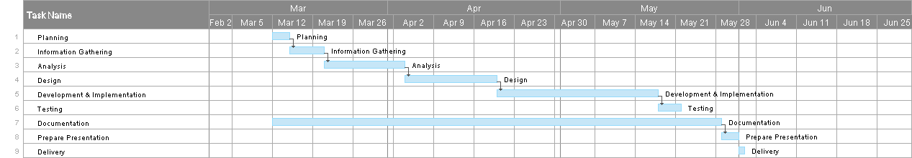

Figure (1): Gant Chart for Events Management systems.

* 1. **Report Outline:**

**Chapter one**

shows a preamble in section 1.1, the project motivation is elaborated in Section 1.2, in additional the problem statement is stated in Section 1.3,Section 1.4, list the project aim and objectives, whereas the project scope is identified in section 1.5, Section 1.6 provide the project software and hardware requirement and Section 1.7 highlights the project limitation, furthermore project expected output is addressed in Section 1.8, whereas the project is scheduled is Section 1.9, the report outline in finally present in Section 1.10.

**Chapter two**

show an introduction in Section 2.1, the existing system is elaborated in Section 2.2, in addition the overall problems of existing system are stated in Section 2.3, Section 2.4, over-all solution approach, whereas the summary is identified in Section 2.5.

**Chapter three**

show an introduction in Section 3.1, requirements elicitation techniques are elaborated in Section 3.2, in addition the targeted users are stated in Section 3.3, Section 3.4, Functional requirements definition and functional requirement specification is identified in Section 3.5, Section 3.6 highlights the non-functional requirements, furthermore summary output is addressed in Section 3.8.

**Chapter four**

an introduction in Section 4.1, Context Diagram elaborated in Section 4.2, then Data Flow Diagram (DFD) in Section 4.3, Section 4.4 provide the Entity Relationship Diagram, in addition the UML, Sequence Diagram is stated in Section 4.5, Section 4.6 include UML Sequence Diagram, Section 4.7 provide UML Class Diagram, furthermore summary output in addressed in Section 4.8.

**Chapter five**

show an introduction in Section 5.1, coding implementation include in Section 5.2, database implementation is elaborated in Section 5.3, in addition the graphical user interface implementation is stated in Section 5.4, Section 5.5, summary.

**Chapter six**

show an introduction in Section 6.1, heuristic evaluation in Section 6.2, in addition the cooperative evaluation is stated in Section 6.3, Section 6.4, requirements validation and completeness Section 6.5 provide system installation and Section 6.6 highlights 6.7 summaries.

**Chapter seven**

shows an introduction in Section 7.1, overall weaknesses are elaborated in Section 7.2, and in addition the overall strengths are stated in Section 7.3 Section 7.4 future work.

# **2.0Chapter Two: Related Existing Systems**

### **Introduction:**

We will compare our application with different applications that have similar functionalities if there are, or to discuss the current scenario for our idea, and show how our application adds more functionalities into an already existing idea, which will improve the overall experience for the user.

### **Existing Systems:**

What's on the current website doesn't include all the events that happen within the university of Jordan, but some of them, so we got to the idea of our site that includes organizing the most important events and to get more than what its exist

This link is the current system in the University of Jordan:

(<http://www.ju.edu.jo/ar/arabic/Lists/UpcomingEvents1/All_Events.aspx>)

### **Overall Problem Statement:**

In the current system, all related People(user) can’t find all information about the Events that happen in the University of Jordan Because the lack of cover details for events., and They need to search about the events on the current website

### **Overall Solution Approach:**

Our idea to develop a new website to include all the events that's happening at the University of Jordan and contain more details about it

### **Summary:**

This chapter describe in briefly the existing system processes and the problem statement inside this existing system in general and what is the approach solution about them inside our project.

# **3.0Chapter Three: System Requirements Engineering and Analysis**

### **Introduction:**

This chapter include in detail about the system requirements and system analysis with full description about the functionality of the system including the definition and the specification for each requirement.

### **Feasibility Study:**

* **Technical Feasibility:**

Our system is developed as interactive web portal for Events Management as web application by using ReactJS (HTML, CSS languages, Bootstrap ) for design and for programming we have use these languages JavaScript , NodeJs , MongoDB for database codes. , and the system will be available all the time and at any place while there is internet connection.

* **Operational Feasibility:**
* Web applications are familiar to wide users, no need too much for training on it, it is easy to use.
* Only the administrator of the system can access the database and modify the data inside it.
* **Economic Feasibility:**
* **Development Cost:**
  + **Personal Cost:**

Table (4): Personal Costs.

|  |  |  |  |
| --- | --- | --- | --- |
| **Employee** | **Cost per hour** | **Hours** | **Total cost per hour** |
| 1 System Analyst | 20 JD | 40 hr | 800 JD |
| 1 System Administrator | 15 JD | 50 hr | 750 JD |
| 2 Programmer | 25 JD | 120 hr | 3000 JD |
| 1 GUI designer | 10 JD | 24 hr | 240 JD |
| 1 Database Specialist | 20 JD | 15 hr | 300 JD |
| Total 5090 JD | | | |

* + **New Hardware’s and Software’s:**

Table (5): New Hardware’s and Software’s.

|  |  |
| --- | --- |
| **Hardware & Software** | **Cost** |
| 1 Computers | 730 JD |
| 1 DBMS Software | 380 JD |
| 1 Development Server | 550 JD |
| Total | 1660 JD |

* + **Development Cost** = 5090 + 1660 = 6750 JD - (For Development Year).
* **Operating Cost:**
  + **Employees:**

2 Programmers (120 hr each 25 JD/hr) = 3000 JD.

1 System Administrator (400 hr each 3 JD/hr) = 1200 JD.

Total= 4200 JD.

* + **Expenses:**

1 Maintenance agreement for server (200 JD).

1 Maintenance agreement for DBMS Software (250 JD).

Total= 450 JD.

* + **Operating Cost** = 4200 + 450 = 4650 JD - (For First Operating Year).
* **Benefits:**
  + **Tangible Benefits:** Benefits that can be measured in money and with certainty that resulted from information forms.

Table (6): Tangible Benefits.

|  |
| --- |
| **TANGIBLE BENEFITS WORKSHEET: Year 1 – 5** |
| 1. Cost reduction or avoidance communication gap in the old system 1,600 JD |
| 2. Error reduction 1,380 JD |
| 3. Increased flexibility 1,280 JD |
| 4. Increased speed of activity 1,760 JD |
| 5. Improvement in management planning or control 2,100 JD |
| **TOTAL Tangible Benefits = 8,120 JD** |

* + **Intangible Benefits:** Benefits that cannot be easily measured in money and with certainty that resulted from information forms.
* Payback Analysis:

Table (7): Payback Analysis.

|  |  |  |  |  |  |  |
| --- | --- | --- | --- | --- | --- | --- |
| Cash flow | Year 0 | Year 1 | Year 2 | Year 3 | Year 4 | Year 5 |
| Development Cost | (6750) | 0 | 0 | 0 | 0 | 0 |
| Operating Cost | 0 | (4650) | (5650) | (6650) | (7650) | (8650) |
| Benefits | 0 | 8120 | 9120 | 10120 | 11120 | 12120 |
| Discount Rate (10%) | 1 | 0.8928 | 0.7971 | 0.7117 | 0.6355 | 0.5674 |
| Time Adjusted Cost | (6750) | (4151.5) | (4503.6) | (4732.8) | (4861.6) | (4908) |
| Time Adjusted Benefits | 0 | 7249.5 | 7269.6 | 7202 | 7067 | 6877 |
| Cumulative Time Adjusted Cost | (6750) | (10901.5) | (15405) | (20137.9) | (24999.5) | (29907.5) |
| Cumulative Time Adjusted Benefits | 0 | 7249.5 | 14519 | 21721 | 28788 | 35665 |
| Cumulative Time Adjusted (Cost& Benefits) | (6750) | (3652) | (886) | 1583.1 | 3788.5 | 5757.5 |

* Payback Year = The Third Year (Year 3).
* Lifetime ROI (Return on Investment) = (35665 – 29907.5) / 29907.5 = 19%, (Estimated Lifetime Benefits - Estimated Lifetime Cost) / Estimated Lifetime Cost = 19%.
* Annual ROI = Lifetime ROI / Lifetime of The System = 0.038 = 4%
* Net Present Value = Cumulative Benefits - Cumulative Cost = 35665 – 29907.5 = 5757.5

### **Requirements Elicitation Techniques:**

Good requirements start with good sources. Finding those quality sources is an important task. After you have identified these sources, there are several techniques that may be used to gather requirements.

**We used the following techniques:**

**interview**

The idea started when we interviewed employees of the Public Relations Department at the University of Jordan, and the main problem was organizing events and activities in paper form, after discusses with Public relations department , we suggested to create a platform that includes events and activities and organize them electronically

**Study existing systems:**

The starting point for many projects is often a similar or an existing system. Sometimes, comparable products and systems contain working versions of good ideas for solving user problems. We can save the time lost in reinventing the wheel by looking at systems already on the market, whether they are systems installed at the user's site or products made by rival organizations.

### **Targeted Users:**

The community of the University of Jordan such students , doctors , stuff working in any related field for the Events .

### **Functional Requirements Definition:**

* **Administrator Section:**

|  |  |  |
| --- | --- | --- |
| FR ID | FR name | Description |
|  | **Sign-In** | The administrator can log into the website using their special domain credentials. |
|  | **Sign-Out** | Allows the administrator to log out from the website. |
|  | **View user** | The administrator can access user information in the dashboard. |
|  | **View Organizers' Form Data:** | The administrator can view details of organizers' forms in the dashboard. |
|  | **update users’ info** | The administrator can modify user information, such as editing their names, in the dashboard. |
|  | **Delete users’ info** | The administrator can delete user accounts. |
|  | **View Events** | The administrator can access event details in the dashboard. |
|  | **Add Events** | The administrator can add events to the website by completing a form in the dashboard. |
| 1. **–** | **Update Events** | The administrator can update event information by clicking the "Update Event" button in the dashboard. |
|  | **Delete Events** | The administrator can remove events by clicking the "Delete Event" button in the dashboard. |

* **Users Section:**

|  |  |  |
| --- | --- | --- |
| FR ID | FR name | Description |
|  | **Sign-In** | The administrator can log into the website using their special domain credentials. |
|  | **Sign-Out** | Allows the administrator to log out from the website. |
|  | **View user** | The administrator can access user information in the dashboard. |
|  | **View Organizers' Form Data:** | The administrator can view details of organizers' forms in the dashboard. |
|  | **update users’ info** | The administrator can modify user information, such as editing their names, in the dashboard. |
|  | **Delete users’ info** | The administrator can delete user accounts. |
|  | **View Events** | The administrator can access event details in the dashboard. |
|  | **Add Events** | The administrator can add events to the website by completing a form in the dashboard. |
|  | **Update Events** | The administrator can update event information by clicking the "Update Event" button in the dashboard. |
|  | **Delete Events** | The administrator can remove events by clicking the "Delete Event" button in the dashboard. |

**-** Organizer Section

|  |  |  |
| --- | --- | --- |
| FR ID | FR name | Description |
|  | Fill Information form | the organizer can request the management of the events by sending the details in the event form. |

### **Functional Requirements Specification:**

### **Non-Functional Requirements:**

Table (8): Non-Functional Requirements.

|  |  |
| --- | --- |
| NON-FUNCTIONAL | description |
| Usability | Simple and easy to use UI. The system should be easy to use, so that users can easily use it without facing difficulties. |
| Security | It can only be accessed by authorized administrators to control the system, by entering their username and password. |
| Availability | The system must be always available when the user needs to use it. |
| Reliability | The system should provide the services as specified; when a user selects the service, he/she wants, the system will respond. |
| Efficiency | preserving system contents, especially when failures occur. |

### **Summary:**

Finally based on the previous titles, this chapter define the SDLC module that we worked on it and include our system requirements and its analysis with full description about the functionality of the system including the definition and the specification for each requirement; also, this chapter include the non-functional requirements that support our system.

# **4. Chapter Four: System Design**

### **Introduction:**

This chapter includes manly important figures that describe our system process, it will include context diagram, data flow diagram (DFD), entity relation diagram (ERD), use cases diagrams, sequences diagrams, class diagrams and user interface (GUI) designs.

### **Context Level:**

Figure (3): Context Level.

### **Data Flow Diagram (DFD)**

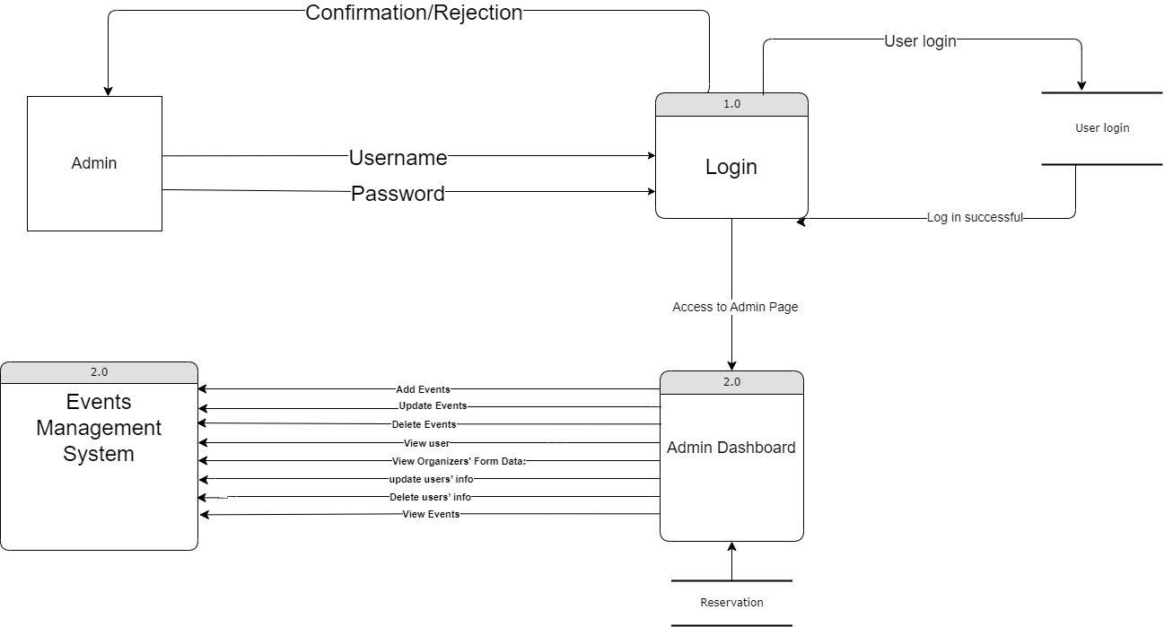

Admin Data Flow Diagram 1

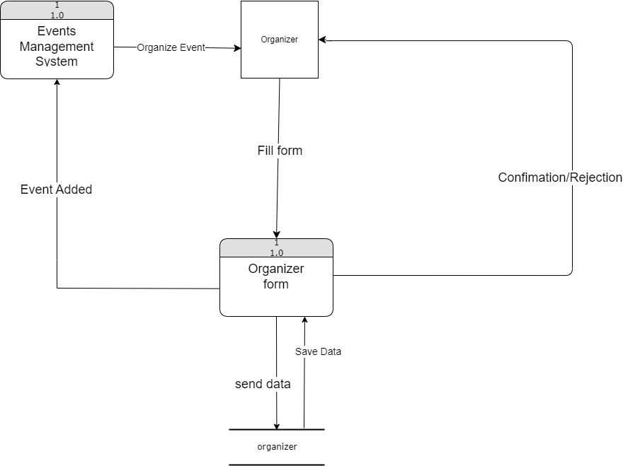

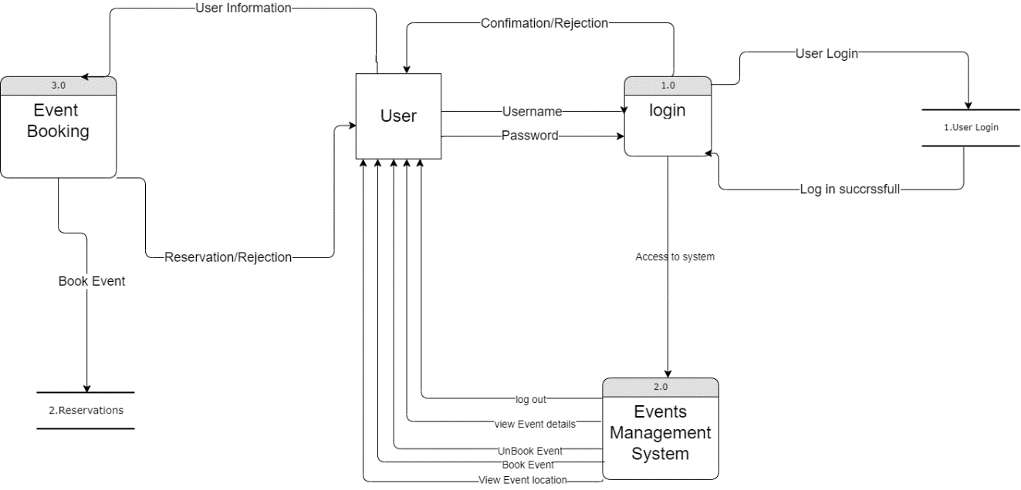–Organizer Data Flow Diagram 1

User Data Flow Diagram 1

Figure (5): Entity Relationship Diagram (ERD).

### **UML Use Case Diagram**

* **Organizer Section:**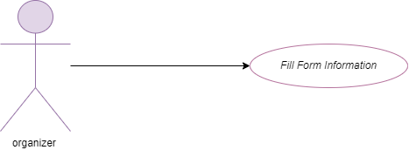
* **User Section**

Figure (6): Organizer Use Case Diagram. 1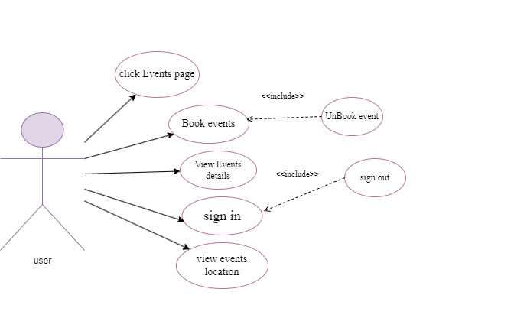

Figure (7): User Use Case Diagram. 1

* Admin Section
* 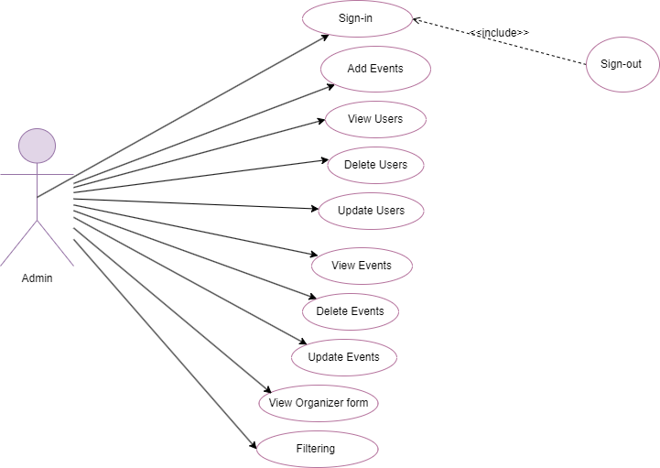

Figure (6): Admin Use Case Diagram. 1

### **UML Sequence Diagram**

* **Administrator Section:**

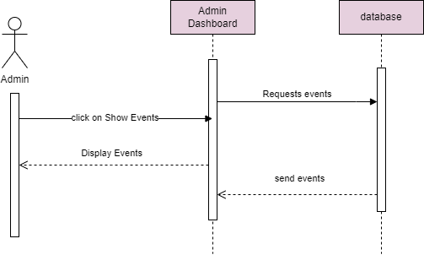

View Events 1

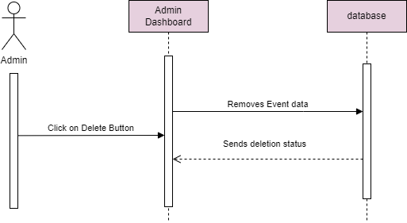

Delete Events 1

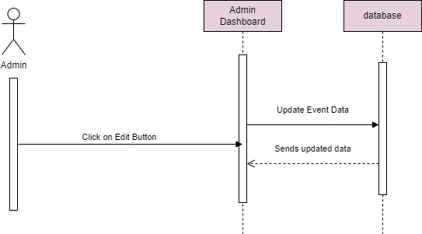

Update Events 1

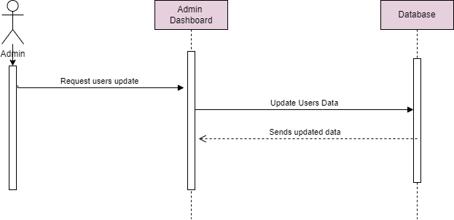

Users Update 1

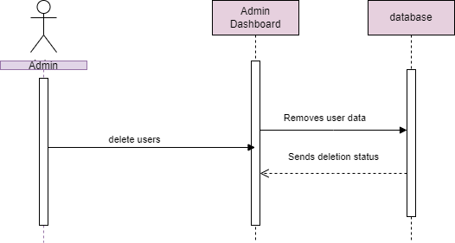

delete Users 1

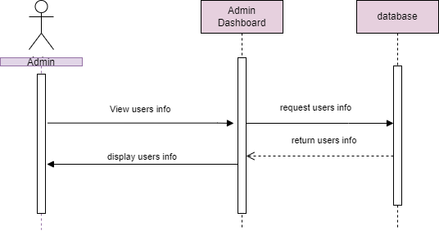

View Users 1

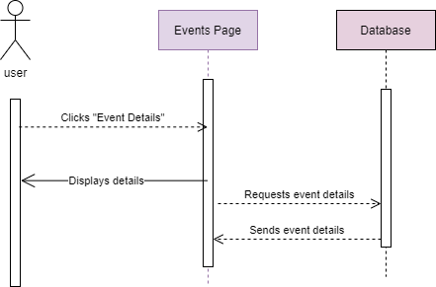

Events Details 1

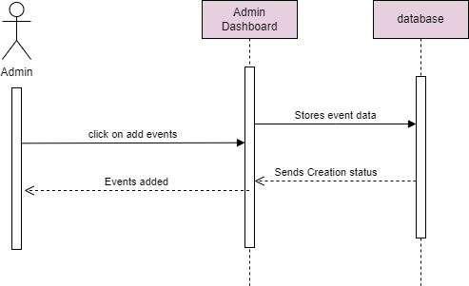

Add Events 1

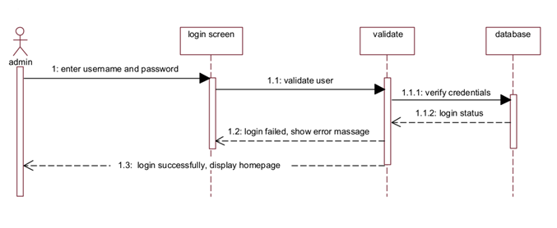

Admin login 1

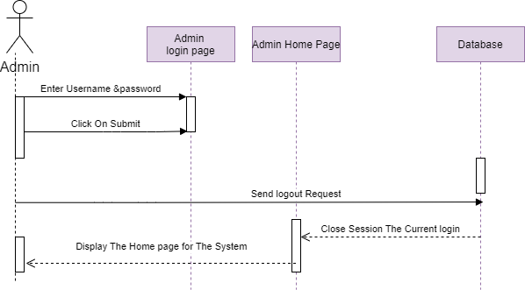

Admin logout 1

* **Users Section:**

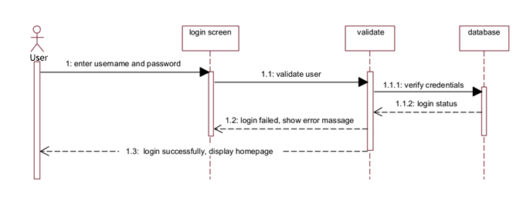

User Login 1

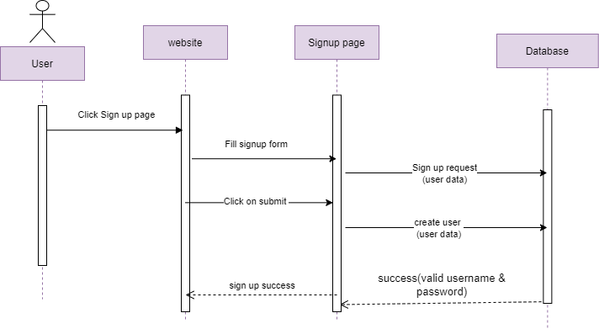

User SignUp 1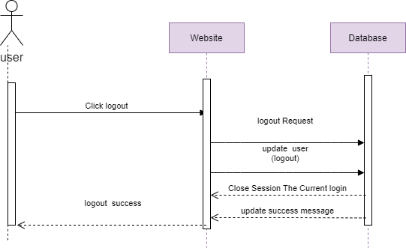

User Logout 1

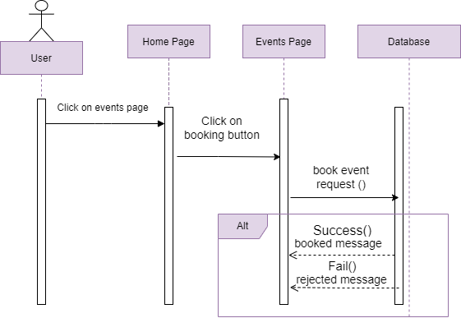

User Booking 1

**-Organizer Section**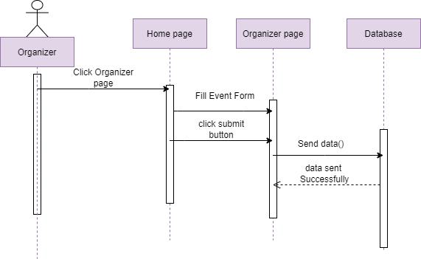

Organizer Form 1

### **Entity Relationship Diagram (ERD)**

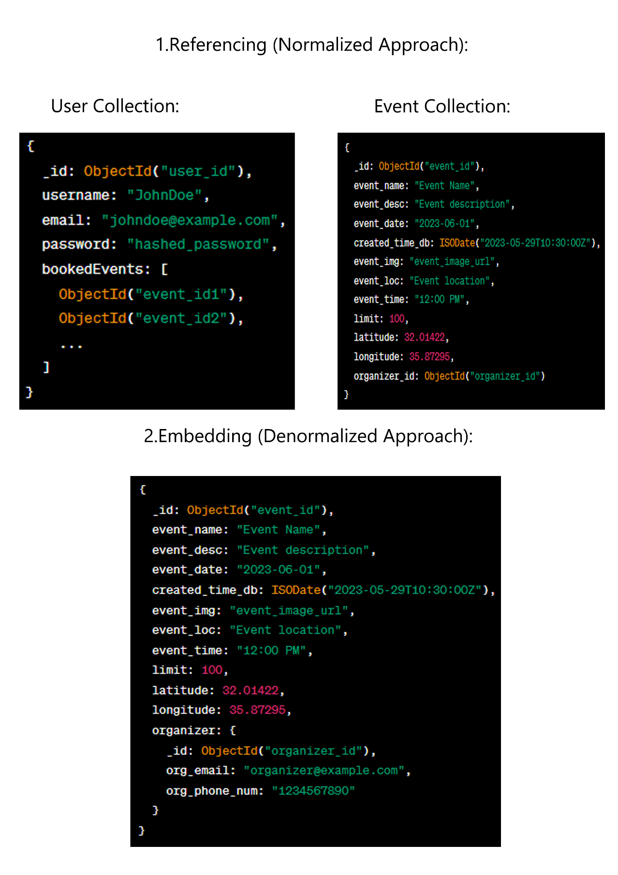

Figure (17): Class Diagram.

### **Summary**

At final, this chapter define our system functionality and how the data transfer inside it the methodology of the system, that we build the context level and 0 level for the system functions, then design the entity relationship diagram for database, after that we identified use cases diagrams, sequence diagrams and class diagram.

# **Chapter Five: System Implementation**

### **Introduction:**

System implementation it is an important phase is the system, at this stage designer start design the system from interface to end of the database implementation. Therefore, this chapter describe the database implementation relations, also the graphical user interface implementation figures.

**Code Implementation:**

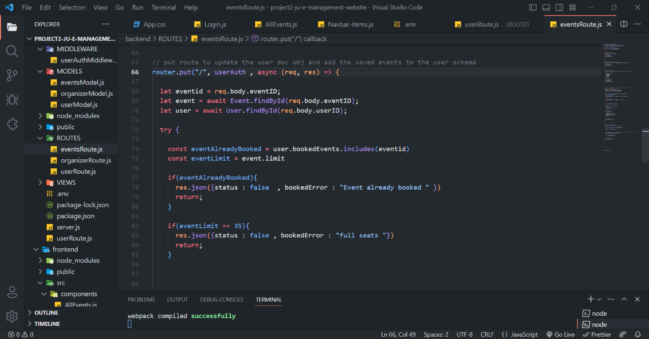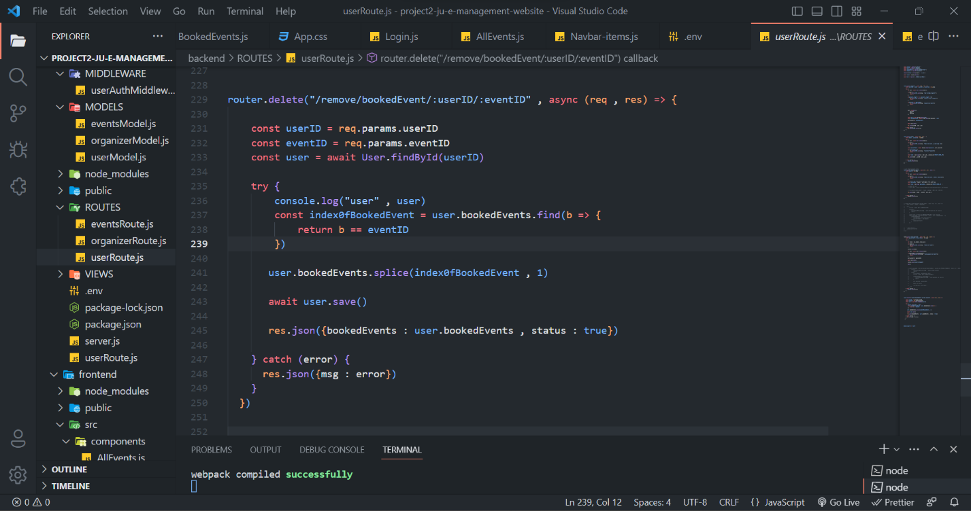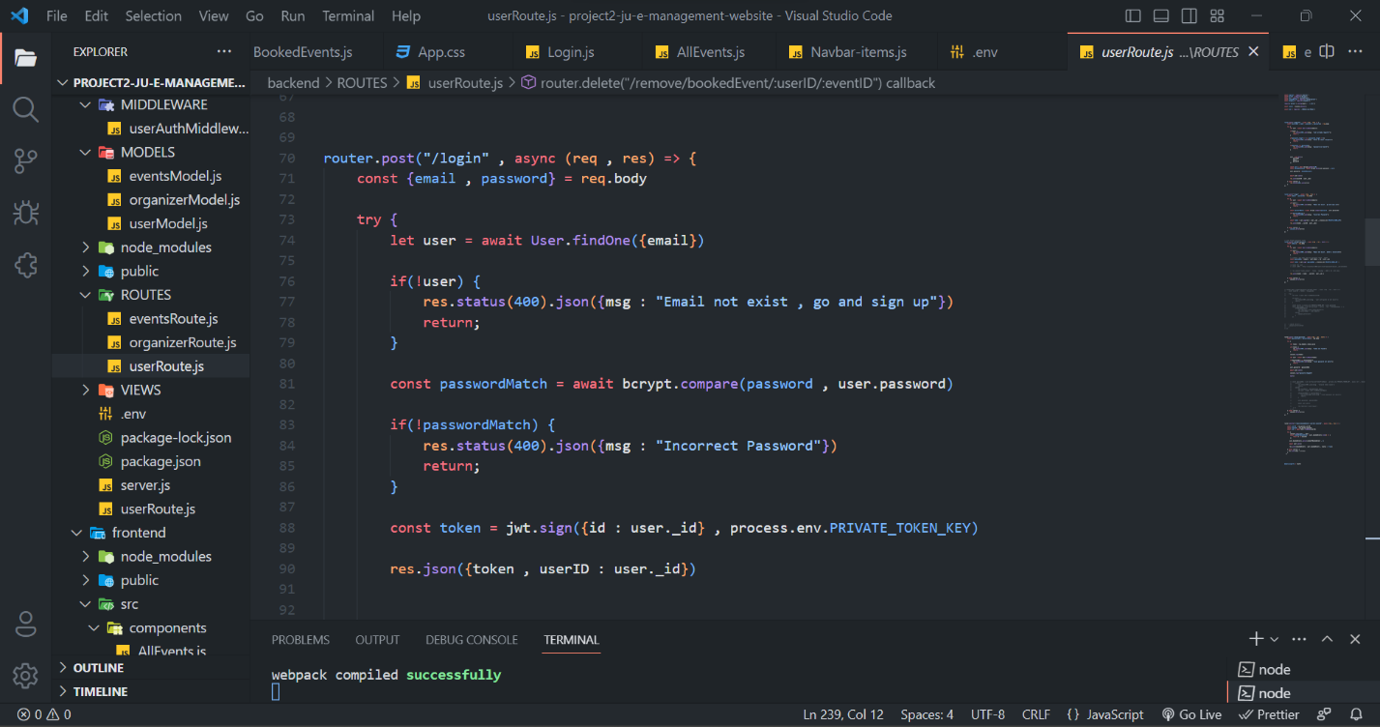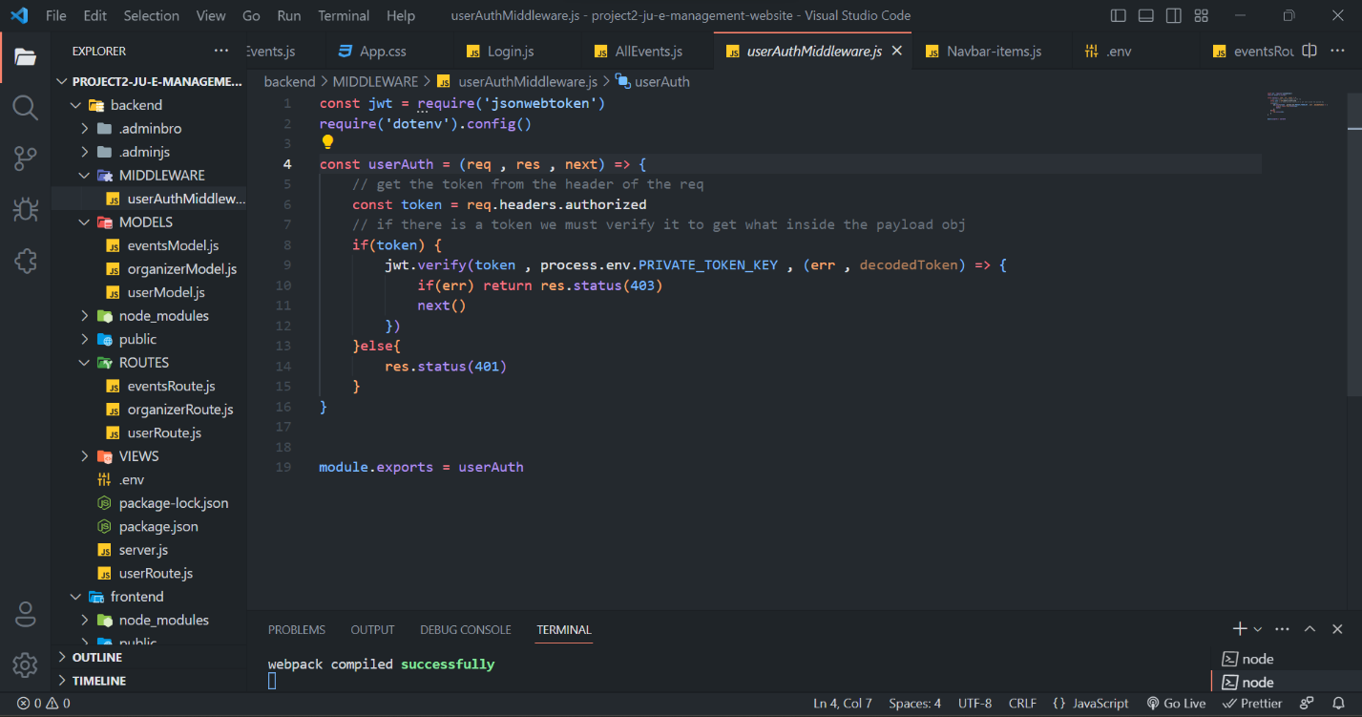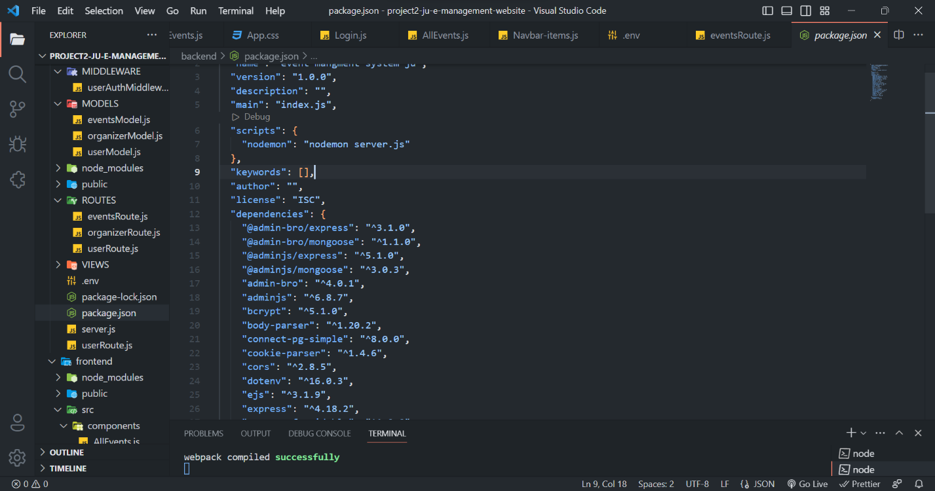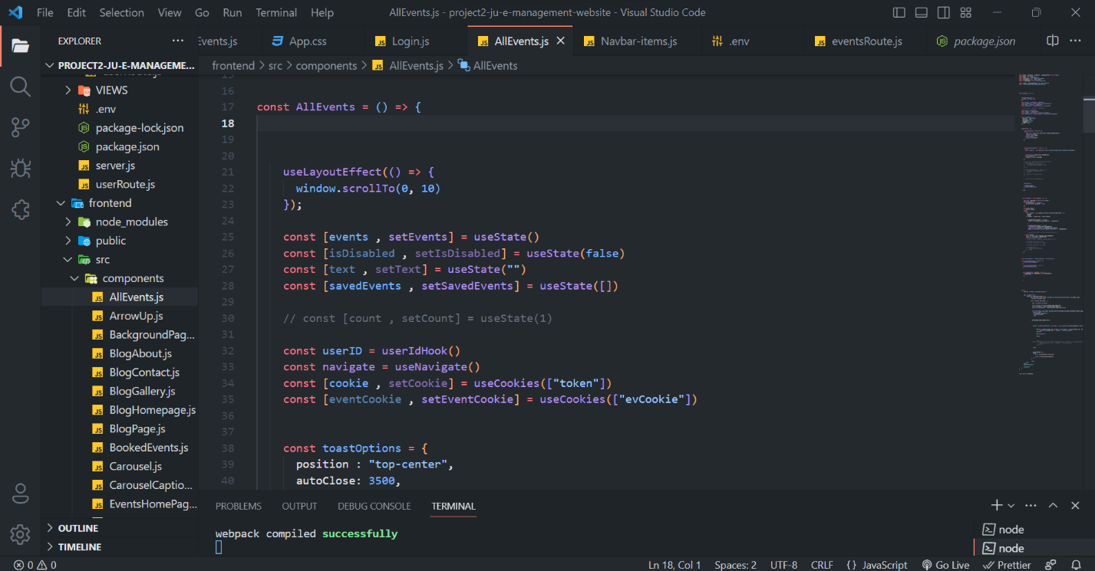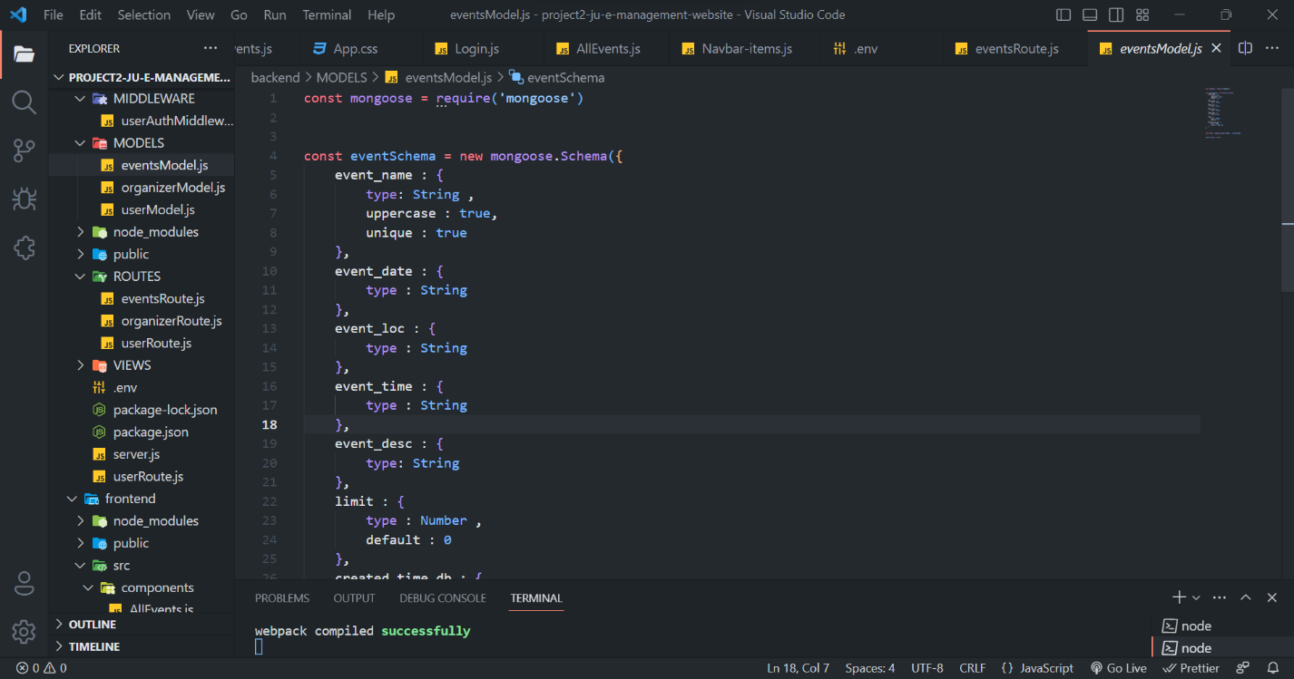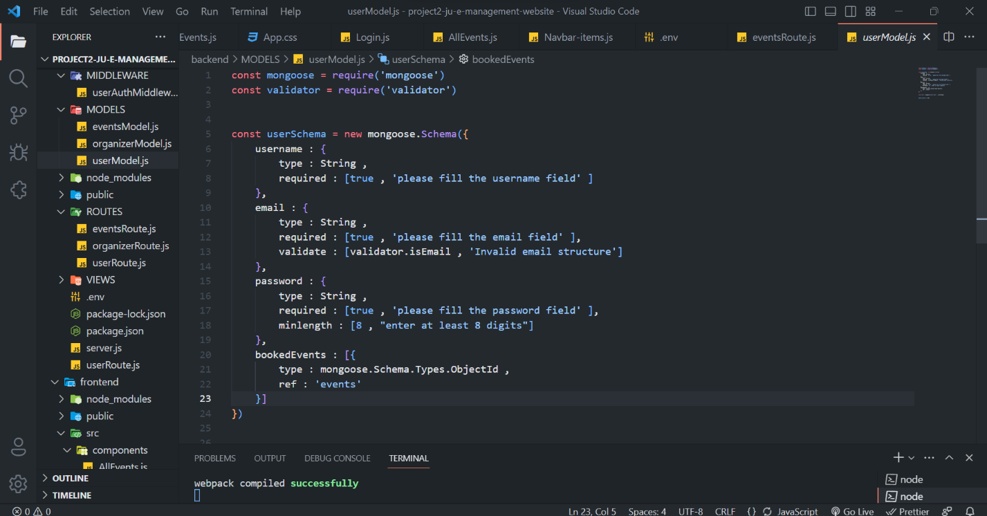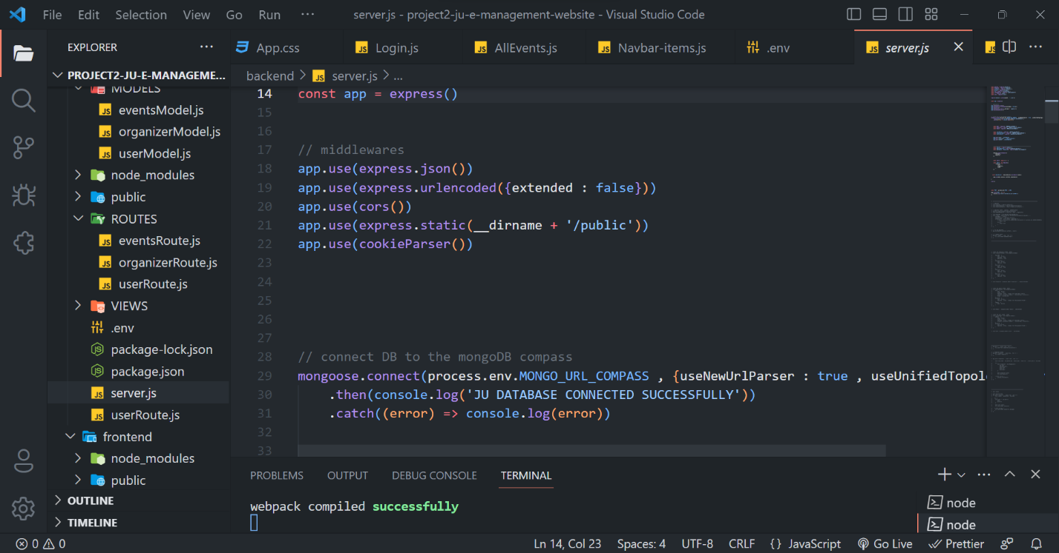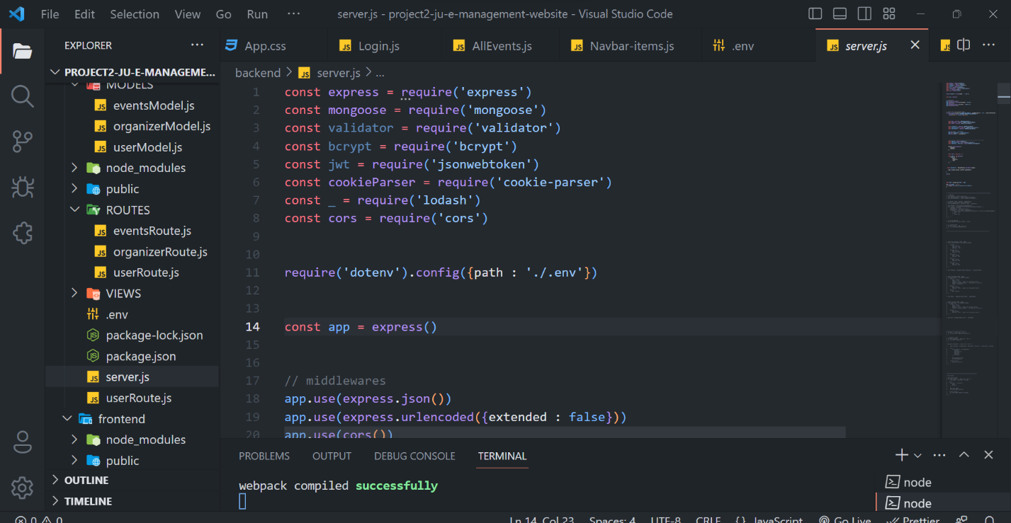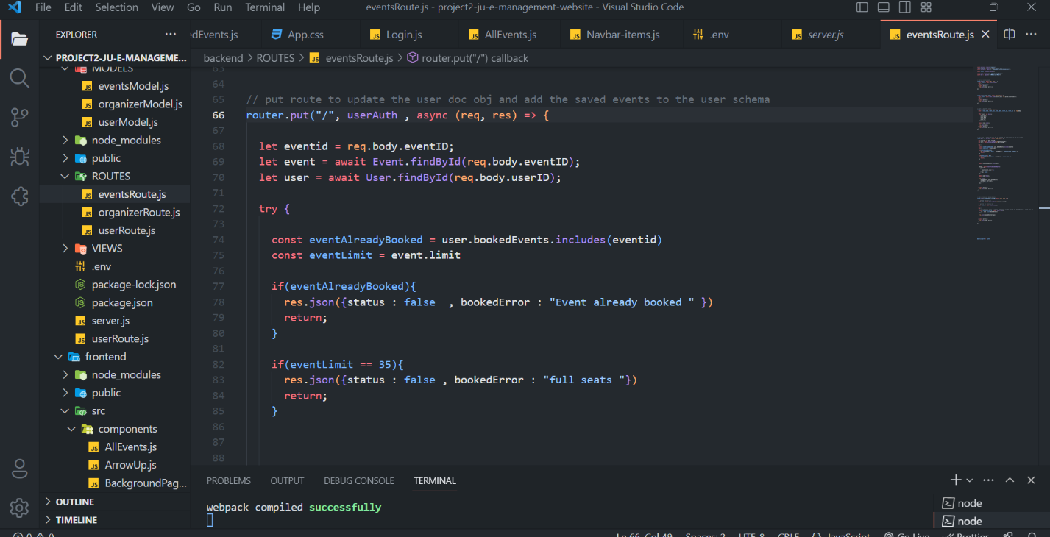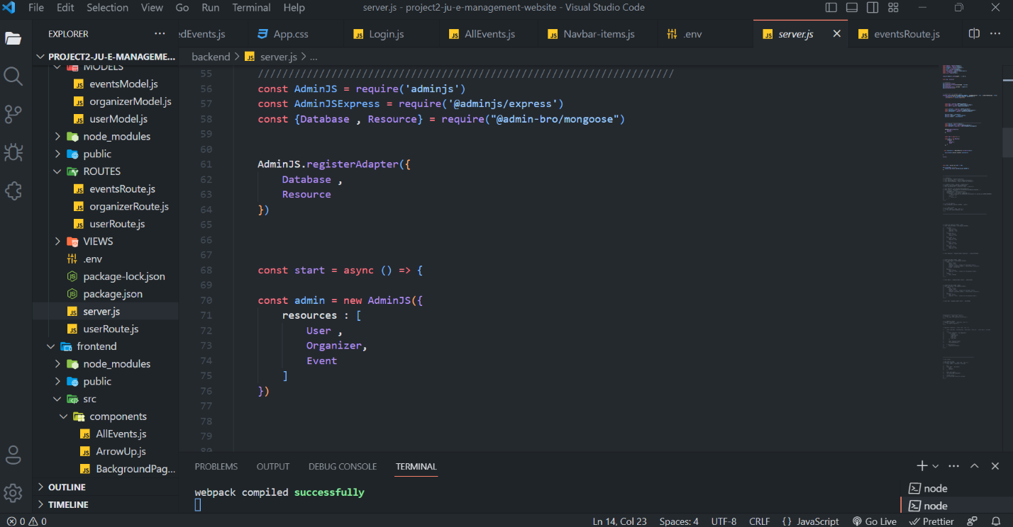

**Graphical User Interface Implementation**

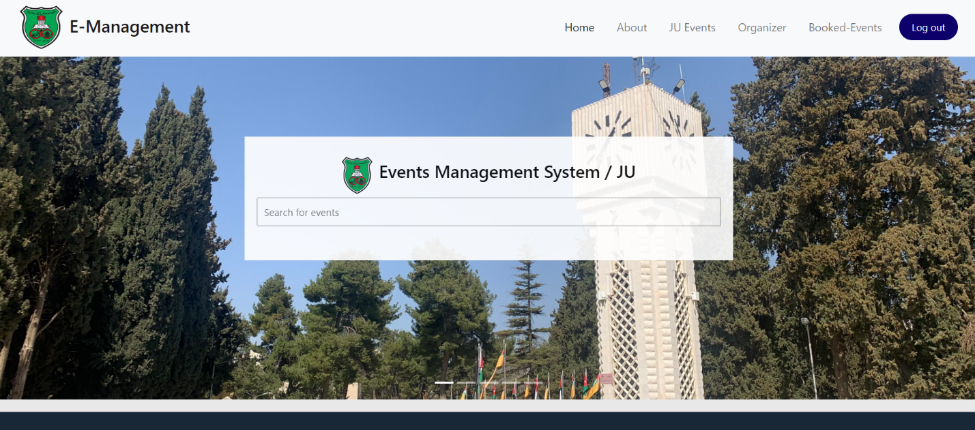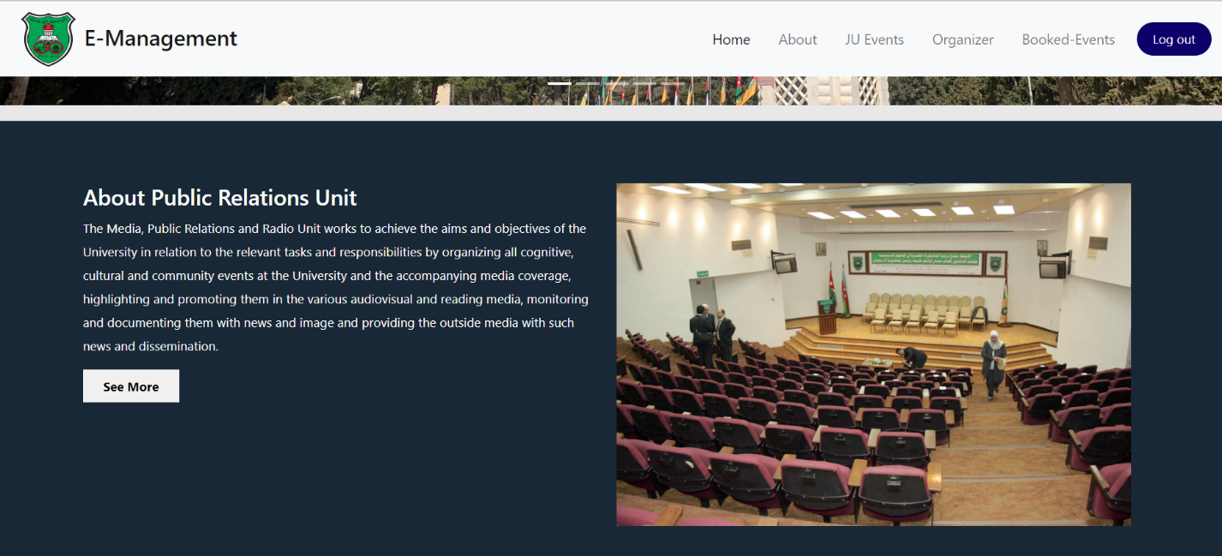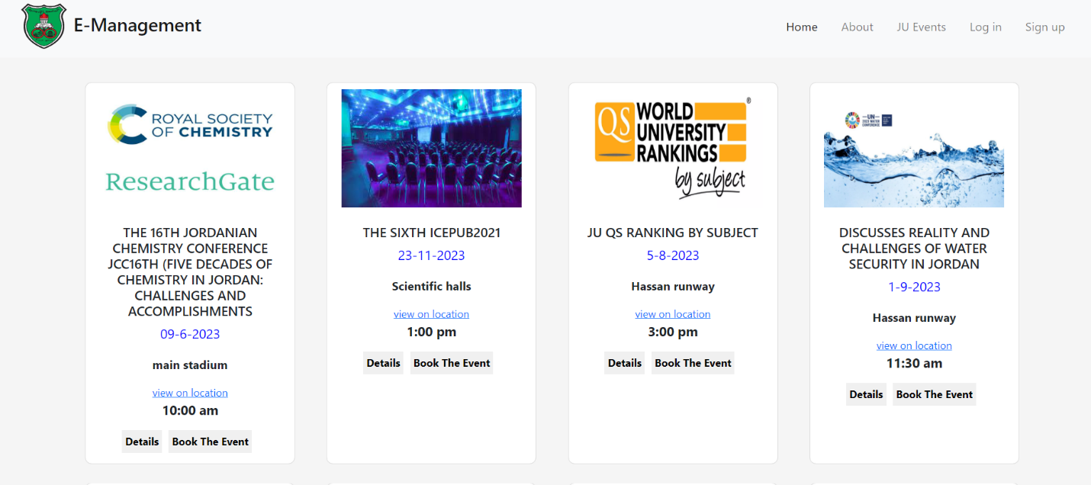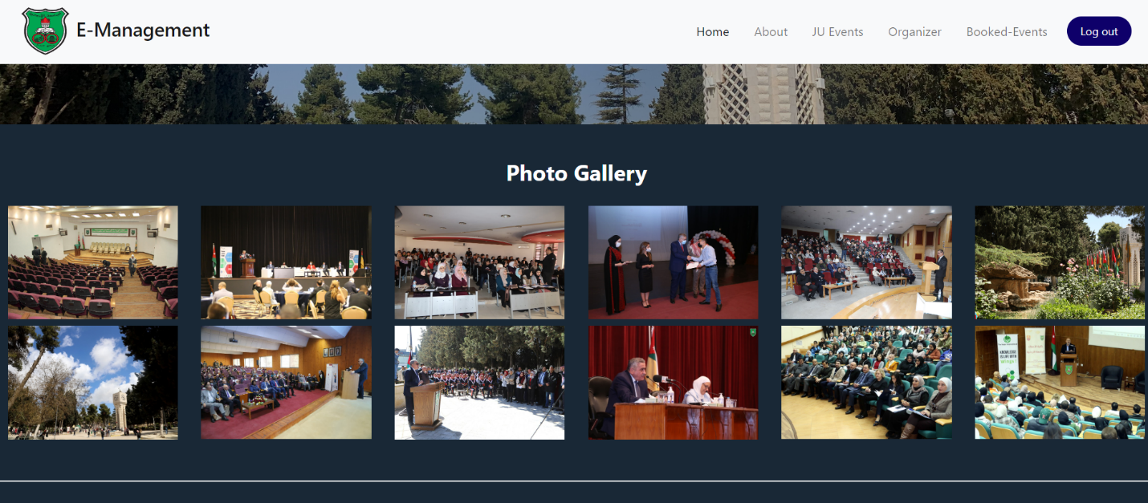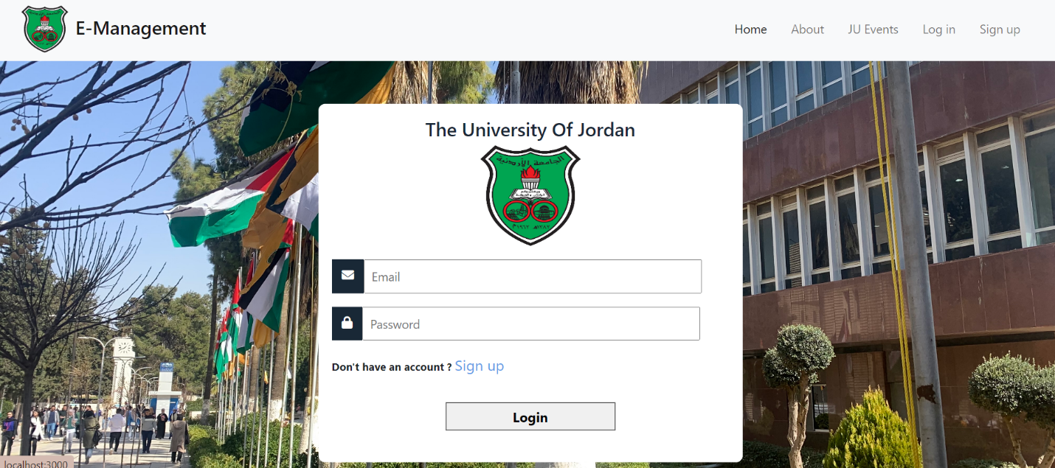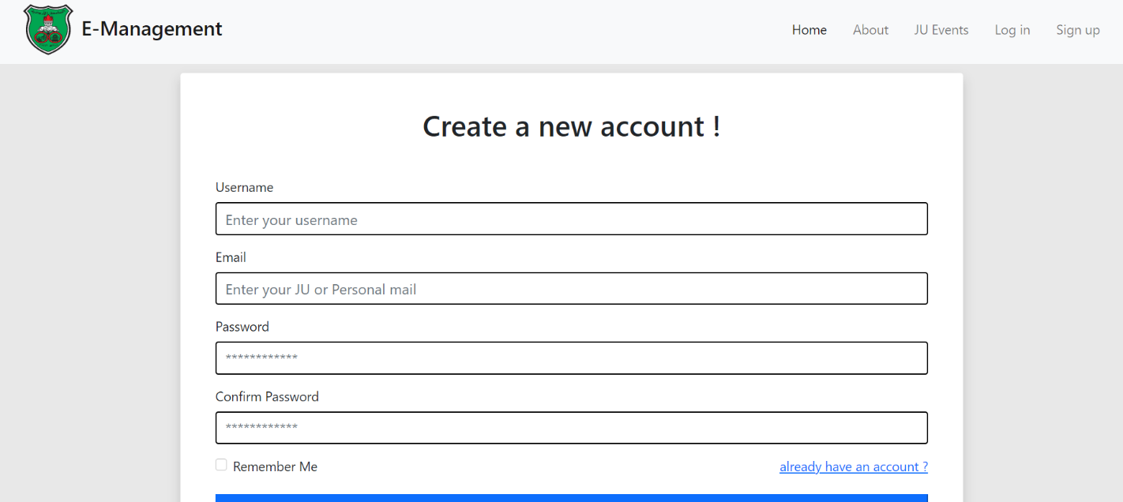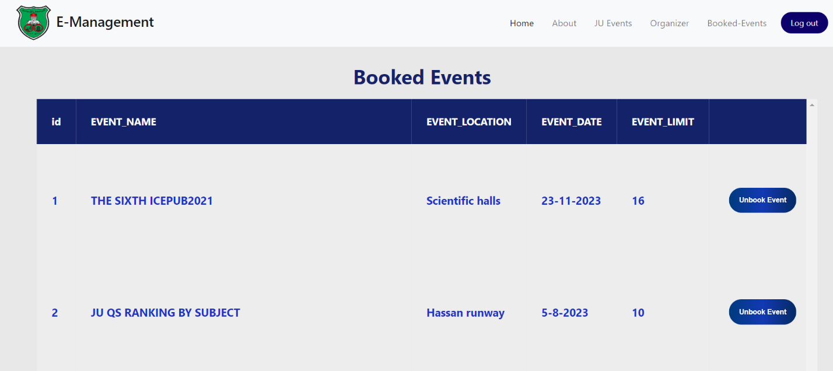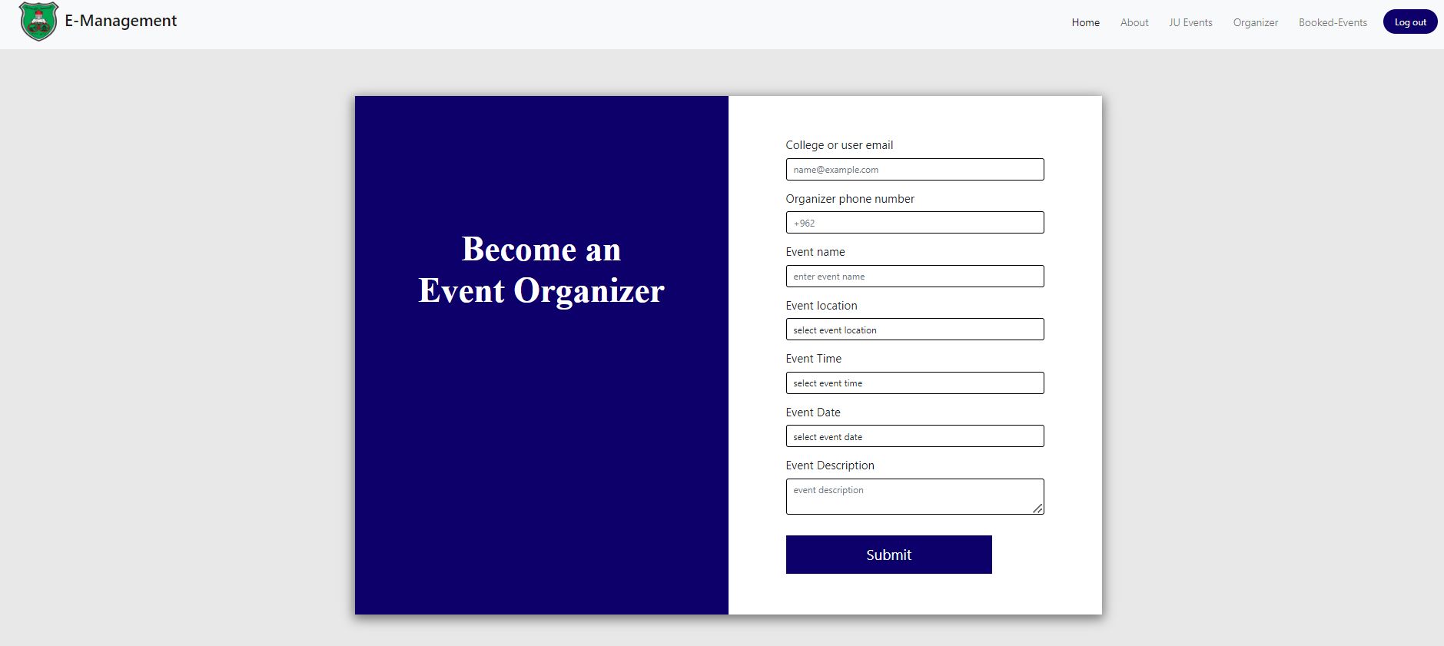

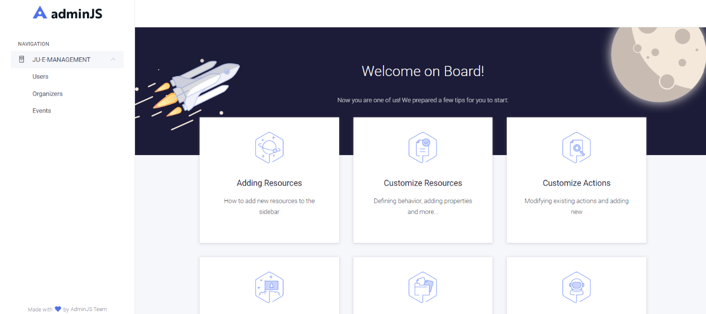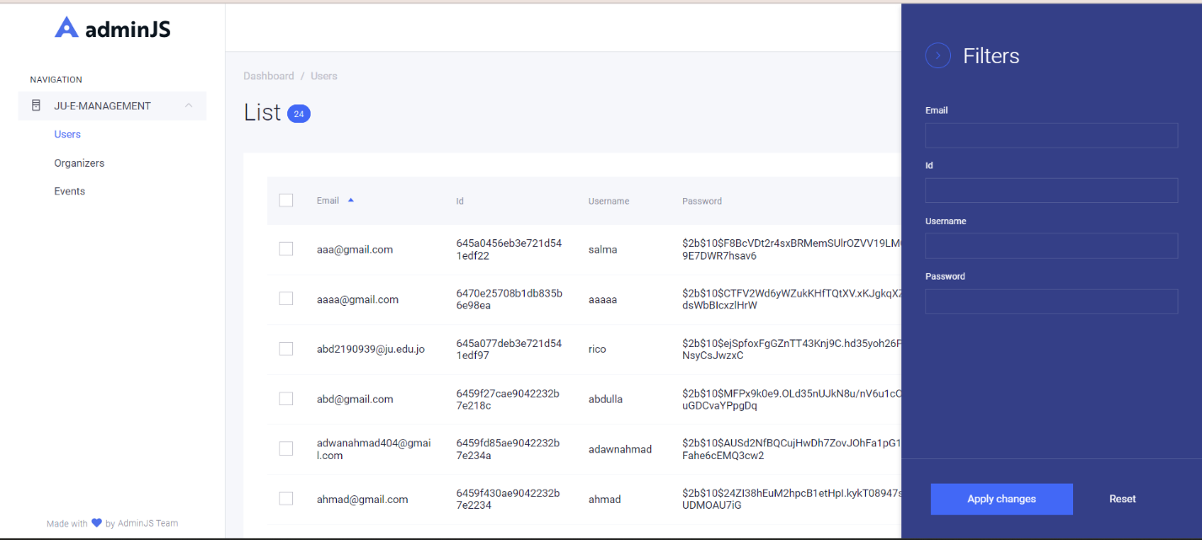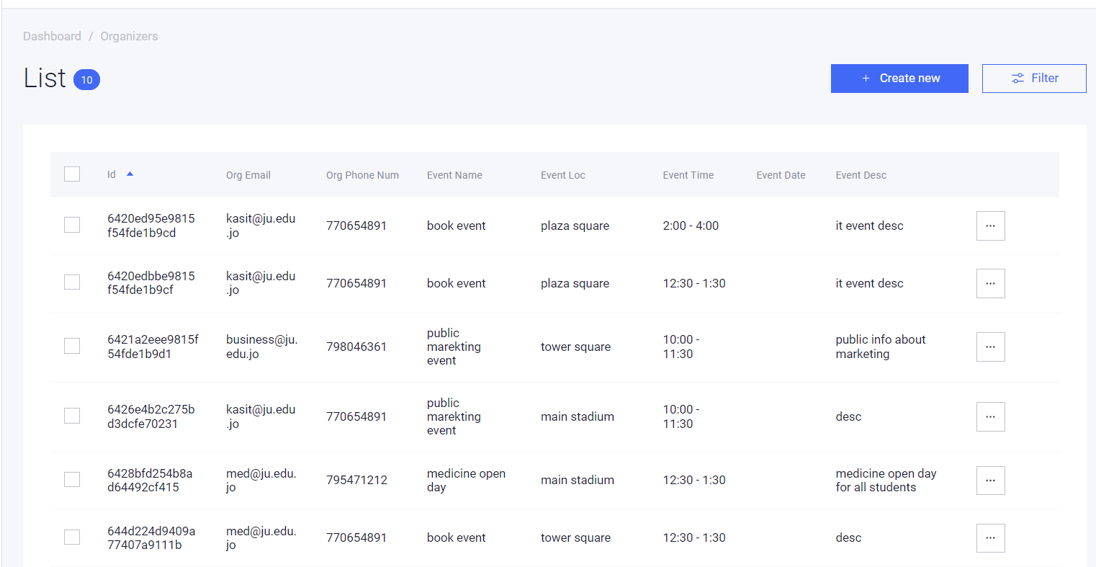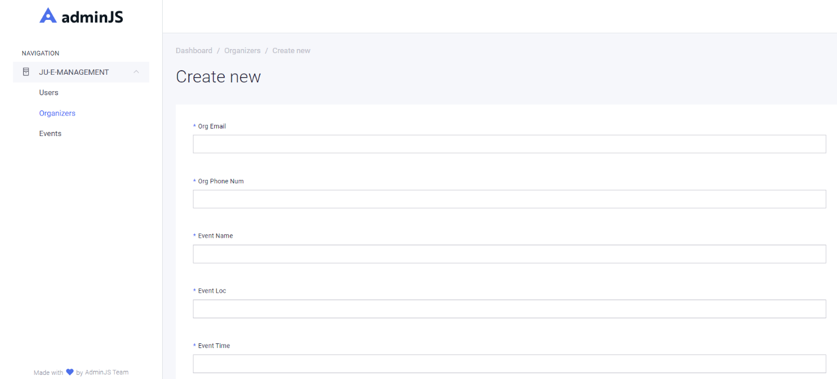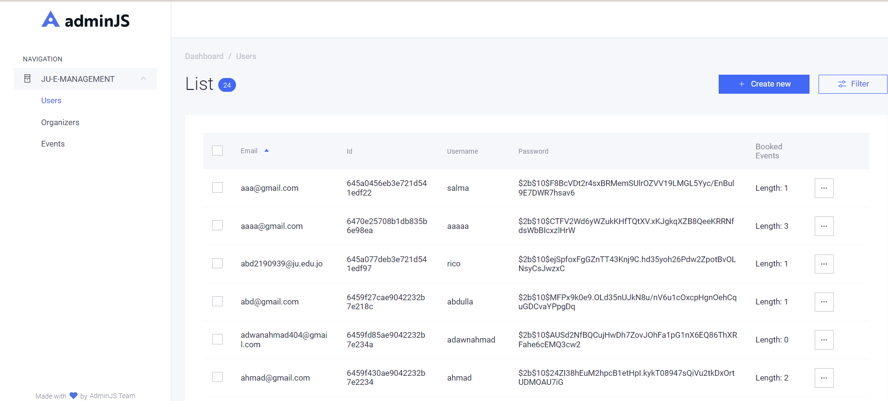

**Summary**

In this chapter shows all implementation details for “Events Management System” including the database and graphical user interface implementation.

The output of this chapter is very necessary for the next chapter, whereby the testing and evaluation take place.

# **6. Chapter Six: System Testing and Installation**

**Introduction:**

In this chapter will we make the test system by certified test globally the Heuristic Evaluation Test and Cooperation Evaluation Test. This chapter present introduction in Section 6.1, heuristic evaluation is elaborate in Section 6.2 in addition the cooperative evaluation is stated in Section 6.3, Section 6.4, system installation. Furthermore, this chapter is finally summarized in Section 6.5.

**Heuristics Evaluation:**

Table (9): Summary of Violations by Heuristics.

|  |  |  |
| --- | --- | --- |
| **Heuristic Numbering Scheme** | **Frequency** | **Ratio (%)** |
| H1 | 5 | 7.576 |
| H2 | 5 | 7.676 |
| H3 | 5 | 7.676 |
| H4 | 10 | 15.152 |
| H5 | 7 | 10.606 |
| H6 | 6 | 9.09 |
| H7 | 8 | 12.121 |
| H8 | 5 | 7.576 |
| H9 | 5 | 7.576 |
| H10 | 10 | 15.152 |
| **Total** | **66** | **100%** |

Table (10): Summary of Violations by Severity Rating For Participant (1).

|  |  |  |
| --- | --- | --- |
| **Severity Rating** | **Frequency** | **Ratio (%)** |
| 0 | 15 | 0.23 |
| 1 | 12 | 0.181 |
| 2 | 10 | 0.151 |
| 3 | 9 | 0.14 |
| 4 | 20 | 0.30 |
| Total | 66 | 100% |

* For more details, refer to Appendix A.

Table (11): Summary of Violations by Severity Rating For Participant (2).

|  |  |  |
| --- | --- | --- |
| **Severity Rating** | **Frequency** | **Ratio (%)** |
| 0 | 9 | 0.14 |
| 1 | 12 | 0.181 |
| 2 | 15 | 0.23 |
| 3 | 10 | 0.151 |
| 4 | 20 | 0.30 |
| Total | 66 | 100% |

* For more details, refer to Appendix A.

Table (12): Summary of Violations by Severity Rating For Participant (3).

|  |  |  |
| --- | --- | --- |
| **Severity Rating** | **Frequency** | **Ratio (%)** |
| 0 | 12 | 0.181 |
| 1 | 10 | 0.151 |
| 2 | 15 | 0.23 |
| 3 | 9 | 0.14 |
| 4 | 20 | 0.30 |
| Total | 66 | 100% |

* For more details, refer to Appendix A.

**Cooperative Evaluation:**

After using the tool and answering the Events Management System test, please indicate the extent to which you agree or disagree with each of the following statements regarding to your experience with the system.

* Cooperative Evaluation:

|  |  |  |  |  |
| --- | --- | --- | --- | --- |
| **No.** | **Criteria** | **Participant 1** | **Participant 2** | **Participant 3** |
| **1.** | **Gender** | male | Female | Female |
| **2.** | **Age** | 23 | 24 | 26 |
| **3.** | **Educational Level** | BA | BA | BA |
| **4.** | **Programmer Taken** | Abdullah | farah | nour |
| **5.** | **Institution** | University of Jordan | University of Jordan | University of Jordan |

Table (13): Participants Details.

**Pre-Evaluation Procedures:**

Participants were contacted through telephone conversations asking them the possibility to participate in the co-operative evaluation. A brief introduction to Events Management System was given to the participants 10 minutes before they started the evaluation, and participants were asked to read that introductory document. The document also has a list of tasks, which will be performed by the participants throughout the co-operative evaluation. Users were told that they need to think aloud when facing any problem in the system. They were also told that, each task they perform is monitored and timed.

**Evaluation Procedures:**

During the evaluation session, a moderator accompanied the users to do the co-operative evaluation. A comment from shown in Appendix B was used by the moderator to write down the comments of each user for each task. Users were helped when they really face serious problems performing the tasks. The following tables show the comments from pre-pared by the moderator for each participant.

Table (14): Cooperative Evaluation for KASIT Attendance System for Participant (1).

|  |  |  |  |
| --- | --- | --- | --- |
| **Task No.** | **Test** | **Time Taken to Complete the Task** | **Comments** |
| **A.** | **Administrator** | | |
| **1.** | **Sign-In** | 20 seconds |  |
| **2.** | **Sign-Out** | 5 seconds |  |
| **3.** | **View user** | 55 seconds |  |
| **4.** | **View Organizers' Form Data:** | 55 seconds |  |
| **5.** | **update users’ info** | 20 seconds |  |
| **6.** | **Delete users’ info** | 55 seconds |  |
| **B.** | Orgainzer | | |
| **1.** | Fill Information form | 20 seconds |  |
| **C.** | Users | | |
| **1.** | Sign-up | 20 seconds |  |
| **2.** | Sign-In | 5 seconds |  |
| **3.** | Sign-Out | 20 seconds |  |
| **4.** | Click Events page | 5 seconds |  |
| **5.** | Book events | 55 seconds |  |
| **6.** | Unbook Events | 5 seconds |  |
| **7.** | View Events Details | 5 seconds |  |
| **8.** | View events location | 10 seconds |  |

Table (15): Cooperative Evaluation for KASIT Attendance System for Participant (2).

|  |  |  |  |
| --- | --- | --- | --- |
| **Task No.** | **Test** | **Time Taken to Complete the Task** | **Comments** |
| **A.** | **Administrator** | | |
| **1.** | **Sign-In** | 20 seconds |  |
| **2.** | **Sign-Out** | 5 seconds |  |
| **3.** | **View user** | 55 seconds |  |
| **4.** | **View Organizers' Form Data:** | 55 seconds |  |
| **5.** | **update users’ info** | 20 seconds |  |
| **6.** | **Delete users’ info** | 55 seconds |  |
| **B.** | Orgainzer | | |
| **1.** | Fill Information form | 20 seconds |  |
| **C.** | Users | | |
| **1.** | Sign-up | 20 seconds |  |
| **2.** | Sign-In | 5 seconds |  |
| **3.** | Sign-Out | 20 seconds |  |
| **4.** | Click Events page | 5 seconds |  |
| **5.** | Book events | 55 seconds |  |
| **6.** | Unbook Events | 5 seconds |  |
| **7.** | View Events Details | 5 seconds |  |
| **8.** | View events location | 10 seconds |  |

Table (16): Cooperative Evaluation for KASIT Attendance System for Participant (3).

|  |  |  |  |
| --- | --- | --- | --- |
| **Task No.** | **Test** | **Time Taken to Complete the Task** | **Comments** |
| **A.** | **Administrator** | | |
| **1.** | **Sign-In** | 20 seconds |  |
| **2.** | **Sign-Out** | 5 seconds |  |
| **3.** | **View user** | 55 seconds |  |
| **4.** | **View Organizers' Form Data:** | 55 seconds |  |
| **5.** | **update users’ info** | 20 seconds |  |
| **6.** | **Delete users’ info** | 55 seconds |  |
| **B.** | Orgainzer | | |
| **1.** | Fill Information form | 20 seconds |  |
| **C.** | Users | | |
| **1.** | Sign-up | 20 seconds |  |
| **2.** | Sign-In | 5 seconds |  |
| **3.** | Sign-Out | 20 seconds |  |
| **4.** | Click Events page | 5 seconds |  |
| **5.** | Book events | 55 seconds |  |
| **6.** | Unbook Events | 5 seconds |  |
| **7.** | View Events Details | 5 seconds |  |
| **8.** | View events location | 10 seconds |  |

* It is important to compare the time taken by each participant to complete each single task com-pared to the default time allocated by the moderator as shown in next table.

Table (17): Task Completion Times in Minutes and Seconds.

|  |  |  |  |  |
| --- | --- | --- | --- | --- |
| **Task No.** | **Default** | **Participant 1** | **Participant 2** | **Participant 3** |
| **A. Administrator Activity** |  | | | |
| **1.** | 10 seconds | 20 seconds | 20 seconds | 20 seconds |
| **2.** | 3 seconds | 5 seconds | 5 seconds | 5 seconds |
| **3.** | 30 seconds | 55 seconds | 55 seconds | 55 seconds |
| **4.** | 30 seconds | 55 seconds | 55 seconds | 55 seconds |
| **B. Instructors Activity** |  | | | |
| **1.** | 10 seconds | 20 seconds | 20 seconds | 20 seconds |
| **2.** | 3 seconds | 5 seconds | 5 seconds | 5 seconds |
| **3.** | 30 seconds | 55 seconds | 55 seconds | 55 seconds |
| **4.** | 30 seconds | 55 seconds | 55 seconds | 55 seconds |
| **C. Students Activity** |  | | | |
| **1.** | 10 seconds | 20 seconds | 20 seconds | 20 seconds |
| **2.** | 3 seconds | 5 seconds | 5 seconds | 5 seconds |
| **3.** | 30 seconds | 55 seconds | 55 seconds | 55 seconds |
| **Total Completion Time** | 3.7 minutes | 5.8 minutes | 5.8 minutes | 5.8 minutes |

* + 1. **Post-Evaluation Procedures:**

After completing the co-operative evaluation, participants were given a post-test questionnaire to fill in, which is shown in Appendix B. This questionnaire was important to capture their thoughts and feelings about Events Management System while they were still fresh. The questionnaire was then followed by a short interview and discussion, which mainly focused on the initial modified design of the Events Management System. Table (18) shows the responses of the 3 participants to the post-test questionnaire.

Table (18): Participants Responses to the Post-Test Questionnaire.

|  |  |  |  |  |  |
| --- | --- | --- | --- | --- | --- |
| **No.** | **Statement** | **Participant 1** | **Participant 2** | **Participant 3** | **Average** |
| **1** | Is the system stable? | 5 | 4 | 4 | **4.3** |
| **2** | Is the system ease of use? | 5 | 5 | 5 | **3** |
| **3** | Are the functionality of the system achieve user’s needs? | 5 | 4 | 5 | **4.6** |
| **Average** | | **5** | **4.3** | **4.6** |  |

**System Installation:**

**Visual studio code:**

<https://code.visualstudio.com/>

**Adobe photoshope CC:**

[**https://www.adobe.com/**](https://www.adobe.com/)

**Operating System (Microsoft Windows 10):**

<http://windows.microsoft.com/en-us/windows/downloads>

**Microsoft Office 2013:**

<http://www.microsoftstore.com/store/msusa/en_US/cat/All-Office/categoryID.69403900>

**Flowcharts Online Maker:**

[**https://draw.io/**](https://draw.io/)

**Summary:**

This chapter showed an intestine testing and evaluation for KASIT Attendance System. The heuristic evaluation was conducted system with 3 expert users. The Heuristic and cooperative evaluation have also shown competitive and acceptable performance for the system indicating that system is easy to use and has less usability problems.

# **Chapter Seven: Project Conclusion and Future Work**

**Introduction:**

Our ultimate goal is to create a website that helps students access and attend the various events taking place within the university, enabling them to benefit from these activities. We aim to enhance these events by providing detailed information and support. Moreover, we seek to assist individuals interested in organizing events at the University of Jordan in connecting with the appropriate department responsible for such matters, namely the Public Relations Department.

**Overall Weaknesses:**

difficulty of obtaining the database for students.

lack of informations about all events at the university of jordan

**Overall Strengths:**

create a dedicated website for organizing events, enabling all students to access and acquire comprehensive details about these activities. The website will allow students to reserve their desired events and empower individuals to organize events within the university.

**Future Work:**

Enabling other universities to organize events occurring at their institutions and linking the website with external entities to facilitate event organization within universities. Additionally, providing the ability to access detailed information about venues and book them accordingly

.**Summary:**

In this chapter we written weaknesses and strengths in order with hope to reduce the weaknesses and focus on future work.

# **APPENDIX A**

**Heuristic Evaluation – A System Checklist**

Disclaimer: This list is a simplified one of the original list which was developed by Xerox Corporation (© Usability Analysis & Design, Xerox Corporation, 1995) and was downloaded from  [ftp://cs.uregina.ca/pub/class/305/lab2/example-he.html](%20ftp://cs.uregina.ca/pub/class/305/lab2/example-he.html). It has been simplified to suite the purpose it is used for, which is to evaluate the KASIT Attendance System in order to identify current problems as experienced by the users, which is part of our graduation project that is submitted to King Abdullah II School for Information Technology, The University of Jordan. The number of questions was reduced; however, the individual questions were left intact.

Please fill in the evaluation form below, which is a form of checklist, by writing “X” in the appropriate place which mostly describes the best answer to the corresponding criterion. This form is to be filled after you have investigated the system interface i.e. have looked at, and examined the interface. The answer to each criterion is either:

* "**0**" which means “I don’t agree that this is a usability problem at all”.
* "**1**" which means “Cosmetic problem only: need not be fixed unless extra time is available on project”.
* "**2**" which means “Minor usability problem: fixing this should be given low priority”.
* "**3**" which means ”Major usability problem: important to fix, so should be given high priority”.
* "**4**" which means ”Usability catastrophe: imperative to fix this before product can be released".

Thank you for your willingness to evaluate this system. Your time and effort are highly appreciated.

**H1. Visibility of System Status**

The system should always keep user informed about what is going on, through appropriate feedback within reasonable time.

|  |  |  |  |
| --- | --- | --- | --- |
| **Number** | **Review Checklist** | **0 1 2 3 4** | **Comments** |
| 1.1 | Does every display begin with a title or header that describes screen contents? | ( ) ( ) ( ) ( ) ( ) |  |
| 1.2 | Do menu instructions, prompts, and error messages appear in the same place(s) on each menu? | ( ) ( ) ( ) ( ) ( ) |  |
| 1.3 | Is there some form of system feedback for every operator action? | ( ) ( ) ( ) ( ) ( ) |  |
| 1.4 | Are responses times appropriate to the users cognitive processing? | ( ) ( ) ( ) ( ) ( ) |  |
| 1.5 | Is there visual feedback in menus or dialog boxes about which choices are selectable? | ( ) ( ) ( ) ( ) ( ) |  |

**H2. Match between System and the Real World**

The system should speak the user’s language, with words, phrases and concepts familiar to the user, rather than system-oriented terms. Follow real-world conventions, making information appear in a natural and logical order.

|  |  |  |  |
| --- | --- | --- | --- |
| **Number** | **Review Checklist** | **0 1 2 3 4** | **Comments** |
| 2.1 | Are icons concrete and familiar? | ( ) ( ) ( ) ( ) ( ) |  |
| 2.2 | Are menu choices ordered in the most logical way, given the user, the item names, and the task variables? | ( ) ( ) ( ) ( ) ( ) |  |
| 2.3 | Do related and interdependent fields appear on the same screen? | ( ) ( ) ( ) ( ) ( ) |  |
| 2.4 | When prompts imply a necessary action, are the words in the message consistent with that action? | ( ) ( ) ( ) ( ) ( ) |  |
| 2.5 | On data entry screens, are tasks described in terminology familiar to users? | ( ) ( ) ( ) ( ) ( ) |  |

**H3. User Control and Freedom**

Users should be free to select and sequence tasks (when appropriate), rather than having the system does this for them. Users often choose system functions by mistake and will need a clearly marked “emergency exit” to leave the unwanted state without having to go through an extended dialogue. Users should make their own decisions (with clear information) regarding the costs of exiting current work. The system should support undo and redo.

|  |  |  |  |
| --- | --- | --- | --- |
| **Number** | **Review Checklist** | **0 1 2 3 4** | **Comments** |
| 3.1 | When a user's task is complete, does the system wait for a signal from the user before processing? | ( ) ( ) ( ) ( ) ( ) |  |
| 3.2 | Are users prompted to confirm commands that have drastic, destructive consequences? | ( ) ( ) ( ) ( ) ( ) |  |
| 3.3 | Are character edits allowed in data entry fields? | ( ) ( ) ( ) ( ) ( ) |  |
| 3.4 | If menu lists are long (more than seven items), can users select an item either by moving the cursor or by typing a mnemonic code? | ( ) ( ) ( ) ( ) ( ) |  |
| 3.5 | If the system uses a pointing device, do users have the option of either clicking on menu items or using a keyboard shortcut? | ( ) ( ) ( ) ( ) ( ) |  |

**H4. Consistency and Standards**

Users should not have to wonder whether different words, situations, or actions mean the same thing. Follow platform conventions.

|  |  |  |  |
| --- | --- | --- | --- |
| **Number** | **Review Checklist** | **0 1 2 3 4** | **Comments** |
| 4.1 | Has a heavy use of all uppercase letters on a screen been avoided? | ( ) ( ) ( ) ( ) ( ) |  |
| 4.2 | Are icons labeled? | ( ) ( ) ( ) ( ) ( ) |  |
| 4.3 | Are there no more than twelve to twenty icon types? | ( ) ( ) ( ) ( ) ( ) |  |
| 4.4 | Does each window have a title? | ( ) ( ) ( ) ( ) ( ) |  |
| 4.5 | Is vertical and horizontal scrolling possible in each window? | ( ) ( ) ( ) ( ) ( ) |  |
| 4.6 | Are menu choice lists presented vertically? | ( ) ( ) ( ) ( ) ( ) |  |
| 4.7 | Are menu titles either centered or left-justified? | ( ) ( ) ( ) ( ) ( ) |  |
| 4.8 | Are menu items left-justified, with the item number or mnemonic preceding the name? | ( ) ( ) ( ) ( ) ( ) |  |
| 4.9 | Do embedded field-level prompts appear to the right of the field label? | ( ) ( ) ( ) ( ) ( ) |  |
| 4.10 | Are attention-getting techniques used with care? | ( ) ( ) ( ) ( ) ( ) |  |

**H5. Help Users Recognize, Diagnose, and Recover From Errors**

Error messages should be expressed in plain language (NO CODES).

|  |  |  |  |
| --- | --- | --- | --- |
| **Number** | **Review Checklist** | **0 1 2 3 4** | **Comments** |
| 5.1 | Is sound used to signal an error? | ( ) ( ) ( ) ( ) ( ) |  |
| 5.2 | Are error messages worded so that the system, not the user, takes the blame? | ( ) ( ) ( ) ( ) ( ) |  |
| 5.3 | Do error messages suggest the cause of the problem? | ( ) ( ) ( ) ( ) ( ) |  |
| 5.4 | Do error messages indicate what action the user needs to take to correct the error? | ( ) ( ) ( ) ( ) ( ) |  |
| 5.5 | If the system supports both novice and expert users, are multiple levels of error-message detail available? | ( ) ( ) ( ) ( ) ( ) |  |
| 5.6 | If an error is detected in a data entry field, does the system place the cursor in that field or highlight the error? | ( ) ( ) ( ) ( ) ( ) |  |
| 5.7 | Do error messages inform the user of the error's severity? | ( ) ( ) ( ) ( ) ( ) |  |

**H6. Error Prevention**

Even better than good error messages is a careful design which prevents a problem from occurring in the first place.

|  |  |  |  |
| --- | --- | --- | --- |
| **Number** | **Review Checklist** | **0 1 2 3 4** | **Comments** |
| 6.1 | Are menu choices logical, distinctive, and mutually exclusive? | ( ) ( ) ( ) ( ) ( ) |  |
| 6.2 | Are data inputs case-blind whenever possible? | ( ) ( ) ( ) ( ) ( ) |  |
| 6.3 | Does the system prevent users from making errors whenever possible? | ( ) ( ) ( ) ( ) ( ) |  |
| 6.4 | Does the system warn users if they are about to make a potentially serious error? | ( ) ( ) ( ) ( ) ( ) |  |
| 6.5 | Do data entry screens and dialog boxes indicate the number of character spaces available in a field? | ( ) ( ) ( ) ( ) ( ) |  |
| 6.6 | Do fields in data entry screens and dialog boxes contain default values when appropriate? | ( ) ( ) ( ) ( ) ( ) |  |

**H7. Recognition Rather Than Recall**

Make objects, actions, and options visible. The user should not have to remember information from one part of the dialogue to another. Instructions for use of the system should be visible or easily retrievable whenever appropriate.

|  |  |  |  |
| --- | --- | --- | --- |
| **Number** | **Review Checklist** | **0 1 2 3 4** | **Comments** |
| 7.1 | For question and answer interfaces, are visual cues and white space used to distinguish questions, prompts, instructions, and user input? | ( ) ( ) ( ) ( ) ( ) |  |
| 7.2 | Are inactive menu items grayed out or omitted? | ( ) ( ) ( ) ( ) ( ) |  |
| 7.3 | Do data entry screens and dialog boxes indicate when fields are optional? | ( ) ( ) ( ) ( ) ( ) |  |
| 7.4 | Are prompts, cues, and messages placed where the eye is likely to be looking on the screen? | ( ) ( ) ( ) ( ) ( ) |  |
| 7.5 | Are field labels close to fields, but separated by at least one space? | ( ) ( ) ( ) ( ) ( ) |  |
| 7.6 | Have items been grouped into logical zones, and have headings been used to distinguish between zones? | ( ) ( ) ( ) ( ) ( ) |  |
| 7.7 | Are borders used to identify meaningful groups? | ( ) ( ) ( ) ( ) ( ) |  |
| 7.8 | Is color coding consistent throughout the system? | ( ) ( ) ( ) ( ) ( ) |  |

**H8. Flexibility and Minimalist Design**

Accelerators-unseen by the novice user-may often speed up the interaction for the expert user such that the system can cater to both inexperienced and experienced users. Allow users to tailor frequent actions. Provide alternative means of access and operation for users who differ from the “average” user (e.g., physical or cognitive ability, culture, language, etc.)

|  |  |  |  |
| --- | --- | --- | --- |
| **Number** | **Review Checklist** | **0 1 2 3 4** | **Comments** |
| 8.1 | If menu lists are short (seven items or fewer), can users select an item by moving the cursor? | ( ) ( ) ( ) ( ) ( ) |  |
| 8.2 | If the system uses a pointing device, do users have the option of either clicking on fields or using a keyboard shortcut? | ( ) ( ) ( ) ( ) ( ) |  |
| 8.3 | On data entry screens, do users have the option of either clicking directly on a field or using a keyboard shortcut? | ( ) ( ) ( ) ( ) ( ) |  |
| 8.4 | On menus, do users have the option of either clicking directly on a menu item or using a keyboard shortcut? | ( ) ( ) ( ) ( ) ( ) |  |
| 8.5 | In dialog boxes, do users have the option of either clicking directly on a dialog box option or using a keyboard shortcut? | ( ) ( ) ( ) ( ) ( ) |  |

**H9. Aesthetic and Minimalist Design**

Dialogues should not contain information which is irrelevant or rarely needed. Every extra unit of information in a dialogue competes with the relevant units of information and diminishes their relative visibility.

|  |  |  |  |
| --- | --- | --- | --- |
| **Number** | **Review Checklist** | **0 1 2 3 4** | **Comments** |
| 9.1 | Are all icons in a set visually and conceptually distinct? | ( ) ( ) ( ) ( ) ( ) |  |
| 9.2 | Does each icon stand out from its background? | ( ) ( ) ( ) ( ) ( ) |  |
| 9.3 | Does each data entry screen have a short, simple, clear, distinctive title? | ( ) ( ) ( ) ( ) ( ) |  |
| 9.4 | Are field labels brief, familiar, and descriptive? | ( ) ( ) ( ) ( ) ( ) |  |
| 9.5 | Are there pop-up or pull-down menus within data entry fields that have many, but well-defined, entry options? | ( ) ( ) ( ) ( ) ( ) |  |

**H10. Help and Documentation**

Even though it is better if the system can be used without documentation, it may be necessary to provide help and documentation. Any such information should be easy to search, focused on the user’s task, list concrete steps to be carried out, and not be too large.

|  |  |  |  |
| --- | --- | --- | --- |
| **Number** | **Review Checklist** | **0 1 2 3 4** | **Comments** |
| 10.1 | Are on-line instructions visually distinct? | ( ) ( ) ( ) ( ) ( ) |  |
| 10.2 | If menu choices are ambiguous, does the system provide additional explanatory information when an item is selected? | ( ) ( ) ( ) ( ) ( ) |  |
| 10.3 | Is the help function visible; for example, a key labeled help or a special menu? | ( ) ( ) ( ) ( ) ( ) |  |
| 10.4 | Navigation: Is information easy to find? | ( ) ( ) ( ) ( ) ( ) |  |
| 10.5 | Presentation: Is the visual layout well designed? | ( ) ( ) ( ) ( ) ( ) |  |
| 10.6 | Conversation: Is the information accurate, complete, and understandable? | ( ) ( ) ( ) ( ) ( ) |  |
| 10.7 | Is the information relevant? | ( ) ( ) ( ) ( ) ( ) |  |
| 10.8 | Can users easily switch between help and their work? | ( ) ( ) ( ) ( ) ( ) |  |
| 10.9 | Is it easy to access and return from the help system? | ( ) ( ) ( ) ( ) ( ) |  |
| 10.10 | Can users resume work where they left off after accessing help? | ( ) ( ) ( ) ( ) ( ) |  |

# **APPENDIX B**

**Cooperative for KASIT Attendance System**

|  |  |  |  |
| --- | --- | --- | --- |
| **Task No.** | **Test** | **Time Taken to Complete the Task** | **Comments** |
| **A.** | Administrator | | |
| **1.** | Sign-up |  |  |
| **2.** | Sign-In |  |  |
| **3**. | Sign-Out |  |  |
| **4.** | Click Events page |  |  |
| **5.** | Book events |  |  |
| **6.** | Unbook Events |  |  |
| **7.** | View Events Details |  |  |
| **8.** | View events location |  |  |
| **B.** | Organizer | | |
| **1.** | Fill Information form |  |  |
| **C.** | user | | |
| **1.** | Sign-up |  |  |
| **2.** | Sign-In |  |  |
| **3.** | Sign-Out |  |  |
| **4.** | Click Events page |  |  |
| **5.** | Book events |  |  |
| **6.** | Unbook Events |  |  |
| **7.** | View Events Details |  |  |
| **8**. | View events location |  |  |

# **APPENDIX C**

**KASIT Attendance System Usability Test (Post-test Questionnaire)**

**Gender:** M / F **Age:** _____

**Educational Level:** ______________________________

**Programmer Taken:** ____________________________

**Institution:** ___________________________________

After using the system and answering KASIT Attendance System test, please indicate the extent to which you agree or disagree with each of the following statements regarding to your experience with the system.

|  |  |  |  |  |  |  |
| --- | --- | --- | --- | --- | --- | --- |
| **No.** | **Statements** | **Strongly Disagree** | **Disagree** | **Neutral** | **Agree** | **Strongly Agree** |
| **1** | **2** | **3** | **4** | **5** |
| **1.** | Is the system stable? |  |  |  |  |  |
| **2.** | Is the system ease of use? |  |  |  |  |  |
| **3.** | Do the functionality of the system achieve user’s needs? |  |  |  |  |  |